*Viruses*

*User Guide*

|  |  |  |
| --- | --- | --- |
| **Supervisor.** | **Sir Ebad Uddin Ahmed** | |
| **Batch.** | **2210C2** | |
| **Group.** | B | |
| **Serial No.** | **Enrollment Number** | **Student Name** |
| 1. | 1424748 | Syed Zamin Abbas Zaidi |
| 2. | 1423493 | M Aqib Zubairi |
| 3. | 1424826 | Syed Abdul Hadi Ali |
| 4. | 1424859 | Sheikh Muhammad Affan |

***Figure 1: Home page to viruses***

* Our Slogan has given to the peoples toward our website.
* OUR HOME PAGE WELCOME OUR CUSTUMERS WITH ATTRACTIVE QOUTE.

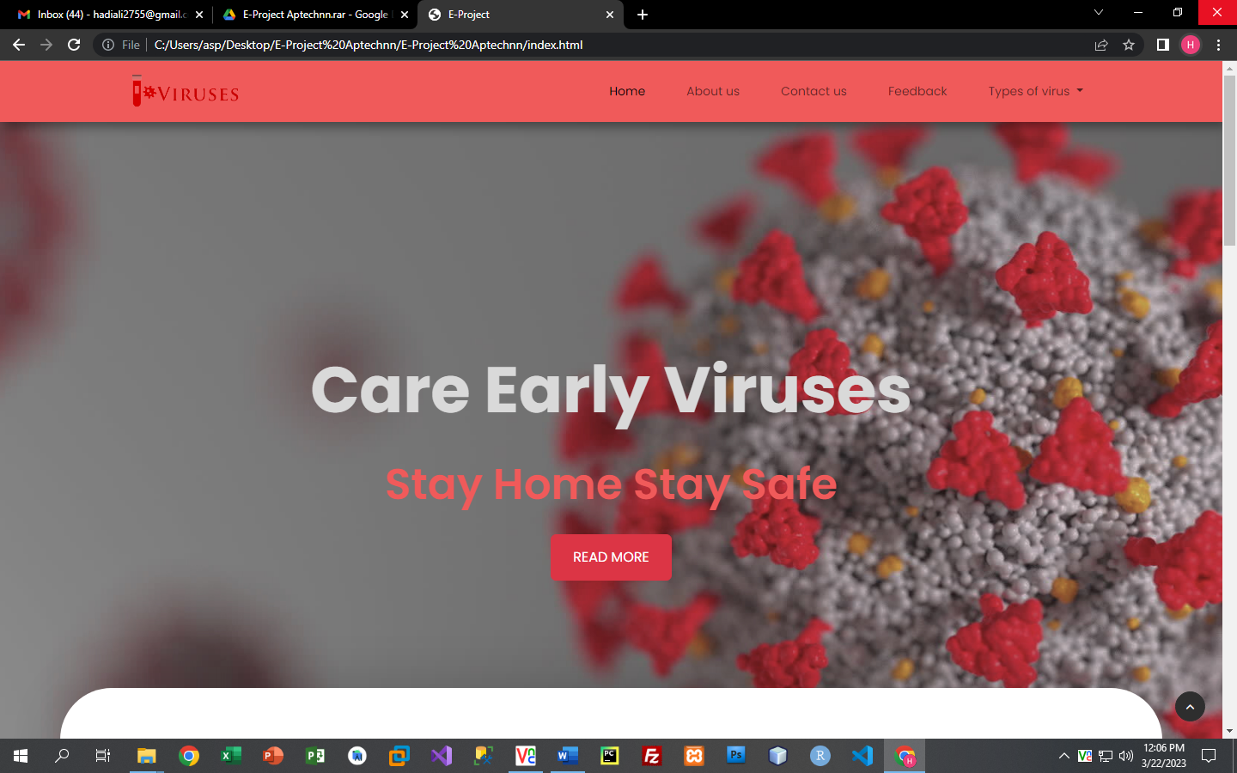

1. **Navbar (index.html)**

**

***Figure 2: Navbar***

We have given FIVE essentials. By clicking any of the essential’s and redirect to the linked page. (Index.html)

1. **CARD (index .html)**

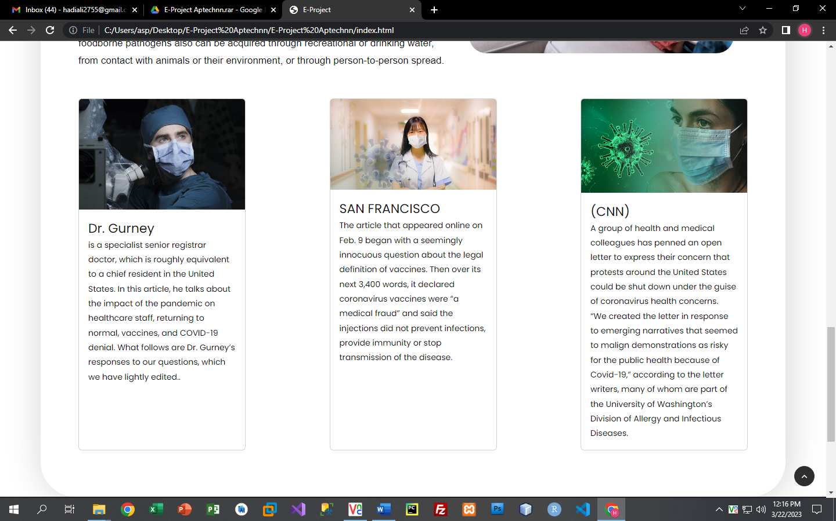

**3.VIRUSES (index .html)**

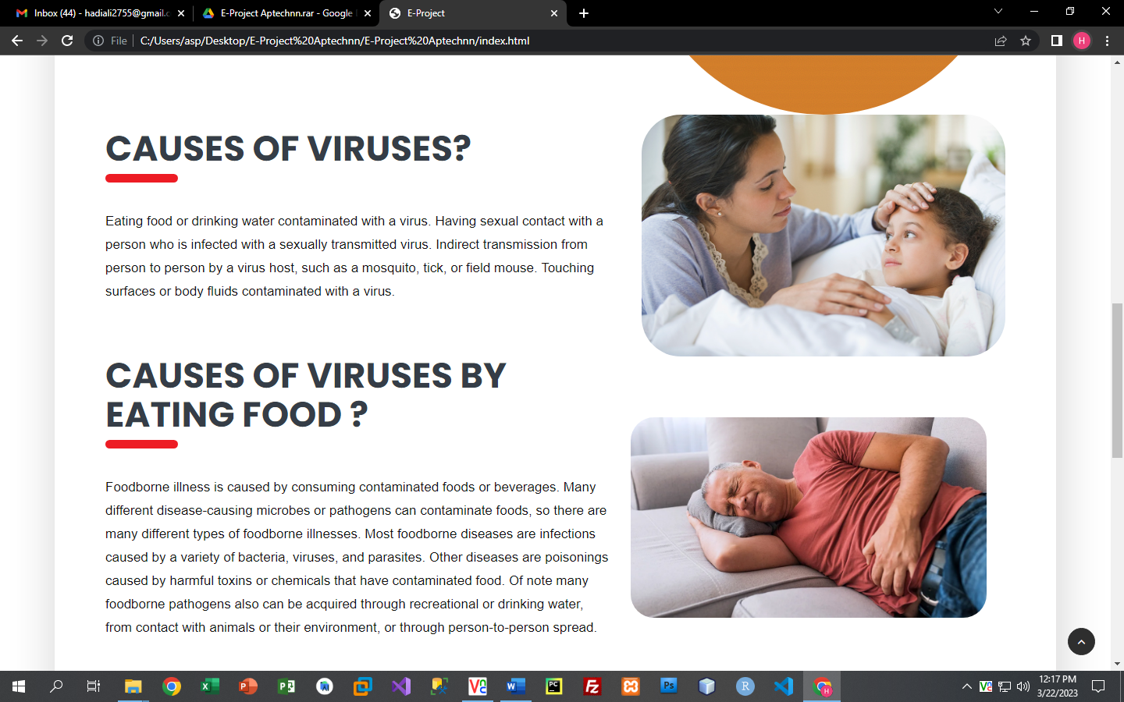

***Figure 3: Types of viruses***

* ***There we show such our viruses.***
* ***There our clients also see our premium quality cabinets.***

***1.Corona virus.(index .html)***

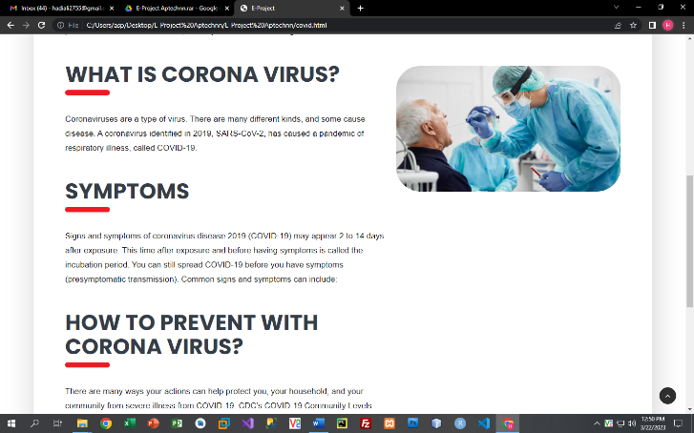

***2.Zika virus.(index .html)***



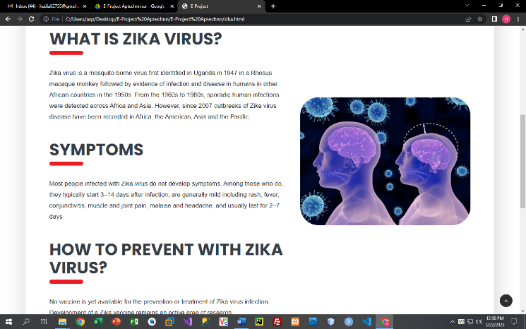

***3.Influenza virus.(index .html)***



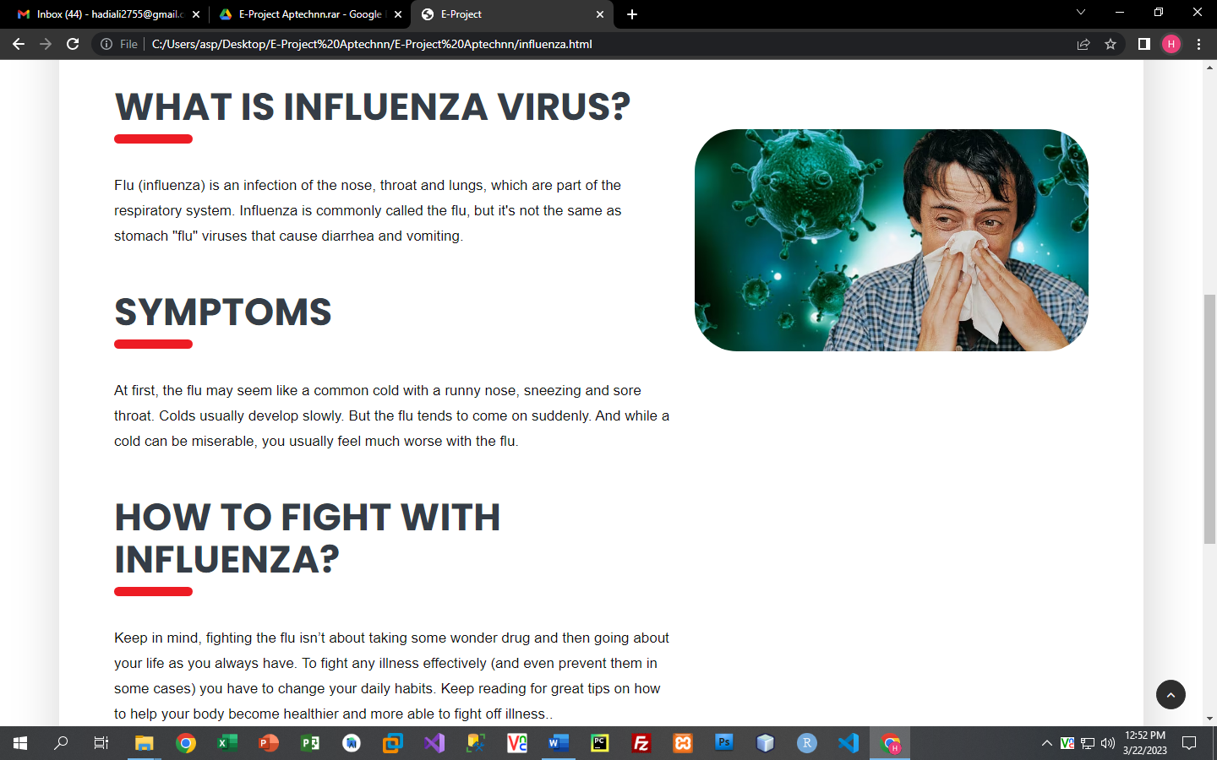

***4.Dengue virus.(index .html)***

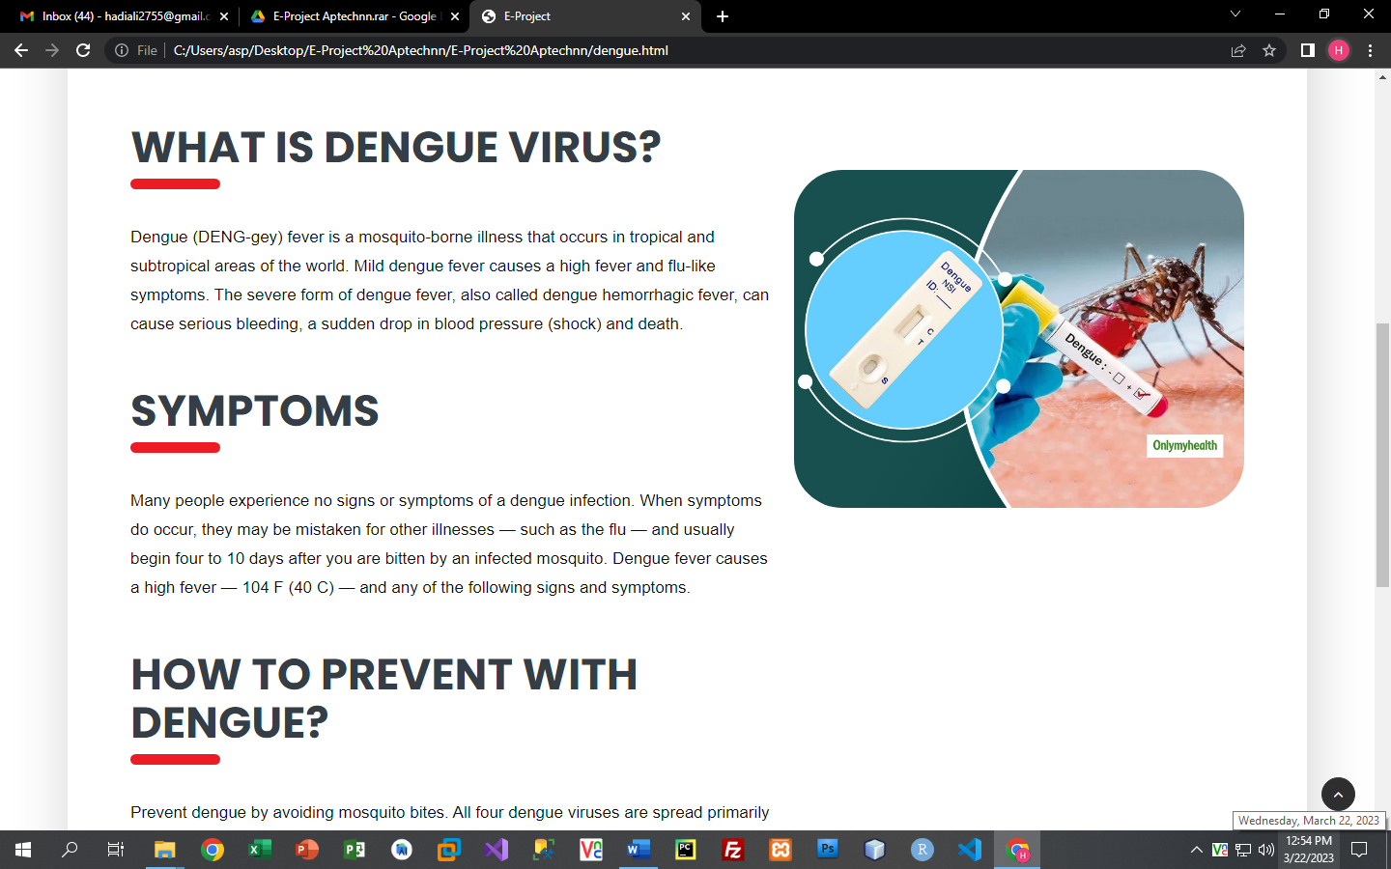

***Figure 4: Registation form***

***6. login(login. Html):***

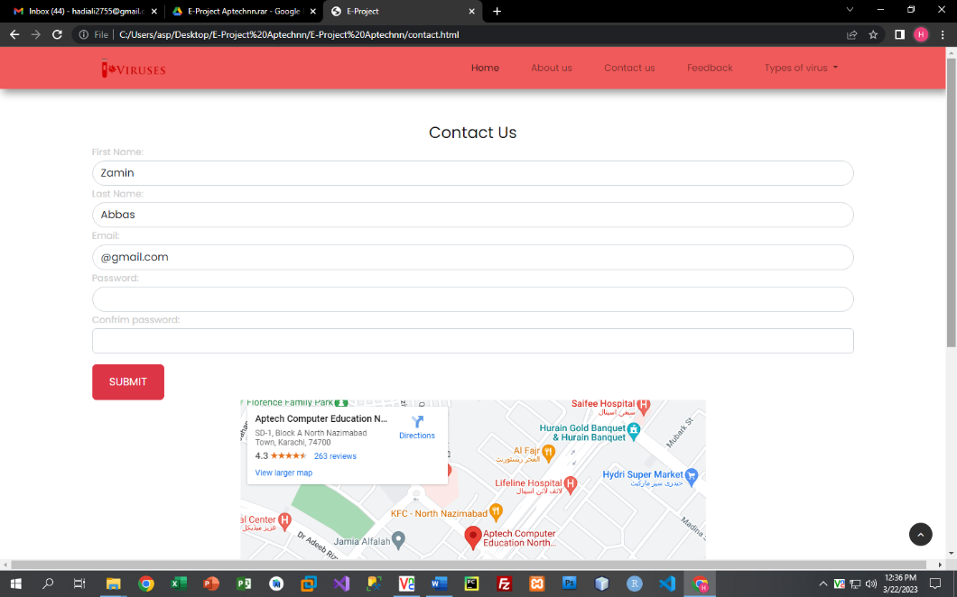

*On clicking login. Login form page open on blank page there customer show two buttons create account button and sing up button with these two options they can create their account or sing in if they have already an account****.***

***7.footer (index .html):***

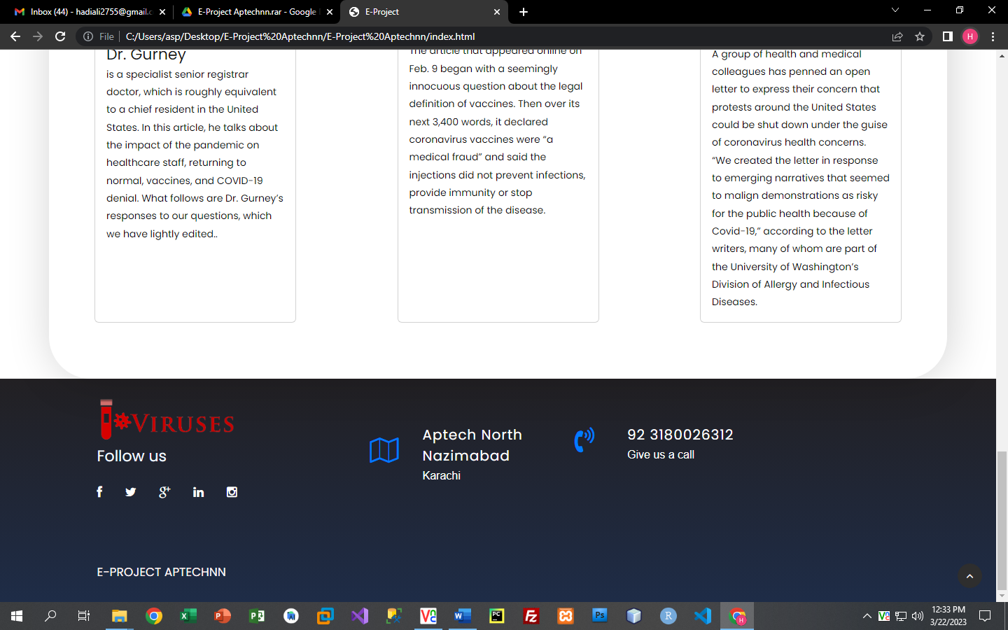

***Figure 14: Footer***

We have given some hover effects in footer to make our website more relaxing.